**COMSATS UNIVERSITY ISLAMABAD, ABBOTTABAD CAMPUS**

**Database System**

**Project Report**

Airline Reservation System

**Submitted by**

Hamid Abdullah FA23-BSE-042

Zeeshan Jamil SP24-BSE-090

Ahmed Tariq FA21-BSE-048

**Submitted to**

Mam Mehwish Sabir

**Table of Contents**

**Airline Reservation System** 3

1.1 Objective 3

1.2 ER Diagram 3

1.3 Table Design 4

1.3.1 User table 4

1.3.2 Login Table23 4

1.3.3 Domestic Flights Table 5

1.3.4 International flight 5

1.3.5 Domestic Booking Info 6

1.3.6 International Booking info 6

1.4 Sample Data 7

1.4.1 User Insert queries 7

1.4.2 Login insert queries 7

1.4.3 Domestic flight insert queries 7

1.4.4 International flight Insert queries 7

1.4.5 Domestic Booking Info Insert queries 8

1.4.6 International booking info insert queries 8

1.5 Sample Queries 8

1.5.1 View All Users 8

1.5.2 All Domestic Flights 8

1.5.3 All International Bookings 9

1.5.4 Bookings by a Specific User 9

1.6 Database Scheme (SQL Code) 10

# Airline Reservation System

## **Objective**

The goal of this project is to develop a Airline Reservation System that allows:

* User registration and login (admin or passenger).
* Viewing flight information (domestic and international).
* Booking domestic and international flights.
* Secure storage of booking and user data.
* Role-based access (admin vs. general user)

## **ER Diagram**

## **Table Design**

* **Users**: Stores account details of users.
* **Login**: Used for system login (linked to Users).
* **flights**: Domestic flight data.
* **International Flights**: International flight data.
* **DomesticBookingInfo**: Details of domestic bookings.
* **InternationalBookingInfo**: Details of international bookings.

Each table includes foreign key constraints, data validation checks, and ensures referential integrity.

### **User table**

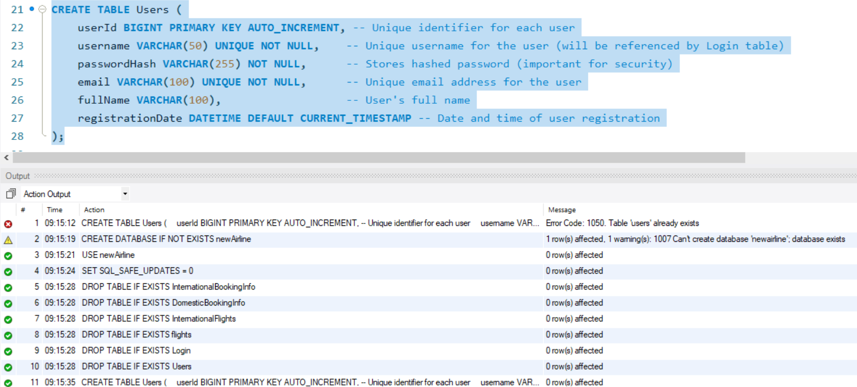

### **Login Table**

### **Domestic Flights Table**

### **International flight**

### **Domestic Booking Info**

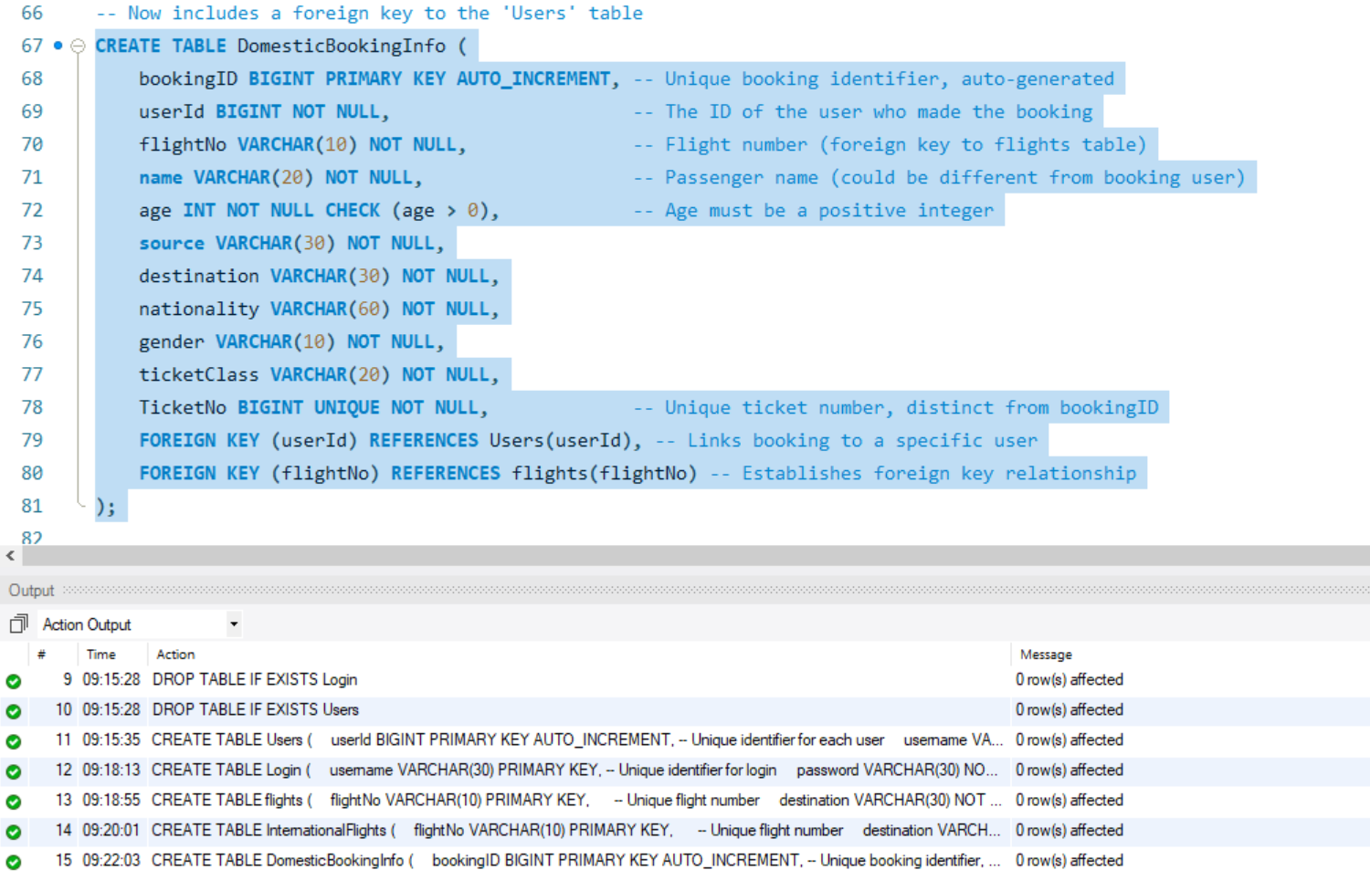

### **International Booking info**

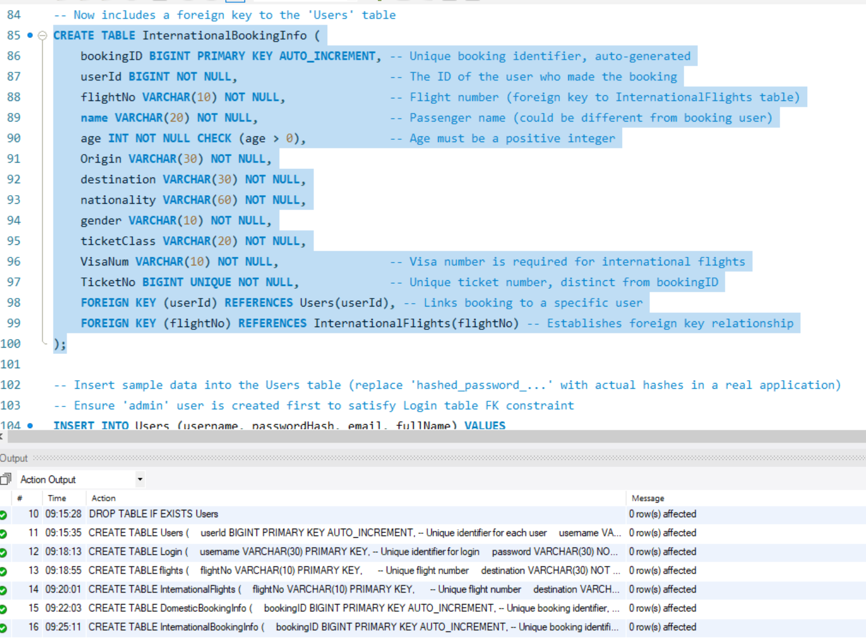

## **Sample Data**

### **User Insert queries**

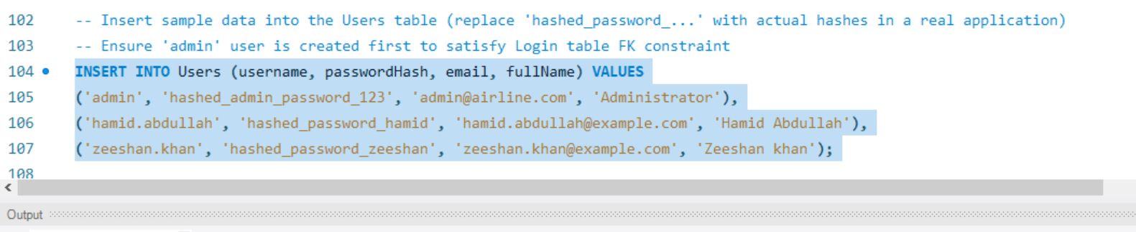

### **Login insert queries**

### 

### **Domestic flight insert queries**

### **International flight Insert queries**

### **Domestic Booking Info Insert queries**



### **International booking info insert queries**



## **Sample Queries**

### **View All Users**

### **All Domestic Flights**

### **All International Bookings**

### **Bookings by a Specific User**

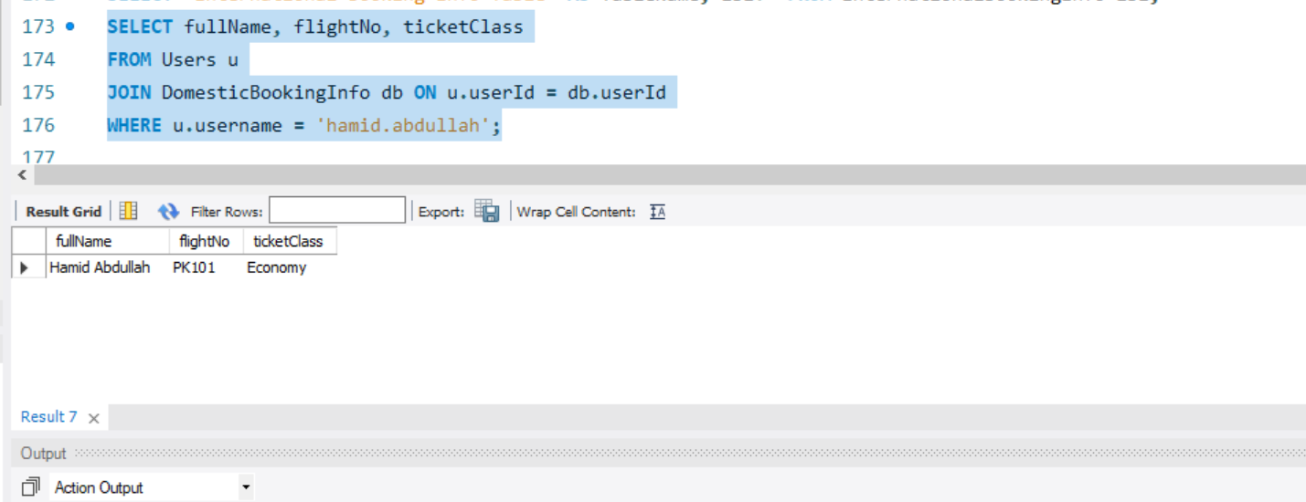

## **Database Scheme (SQL Code)**



